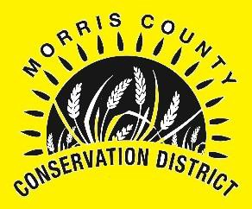
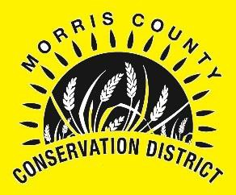
MORRIS COUNTY CONSERVATION DISTRICT SENIOR HIGH SCHOOL
SCHOLARSHIP APPLICATION

Name of Applicant: Mailing Address: City, State, Zip: Daytime Phone:
E-Mail Address: Grade Point Average: High School:
College or University to Attend: College Major:
$500.00 Scholarship ($250.00 per Semester)
*Copy of Grades with a Minimum of 2.0 GPA Required for 2nd Payment!
ITEMS REQUIRED WITH APPLICATION (Applicant must be pursuing a degree in a natural resource field.) Examples: Range Management, Plant Sciences, Agronomy, Agriculture Technology Management, Animal Science, Ag Education, Feed Science, and any other “natural resource” field.
- Copy of School Transcript
- Two Letters of Recommendation (not relatives)

Signature of Applicant Date

On a separate piece of paper, please type a 500 word essay explaining why conservation and water quality are important to you, and tell how this scholarship will benefit you personally and/or professionally. Deadline for applications and all requested materials will be December 15, 2023. Scholarship will be presented at the Morris County Conservation District's Annual Meeting scheduled for January 27, 2024.
.
Submit application to:
Morris County Conservation District 116 Fox Street
Council Grove, KS 66846-1219

For more information or if you have any questions, please contact us at: 620-767-5111 Ext. 101 or contact or visit http://www.morriscountyconservationdistrict.com/.

*WATER QUALITY *CONSERVATION *DEVELOPMENT *SELF-GOVERNMENT

